**Name: Trần Hữu Đạt**

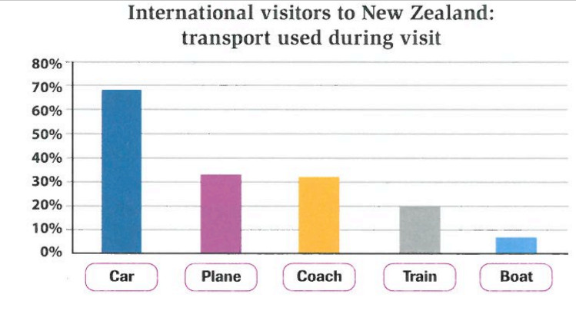**MSSV: 522H0081**

The line graph gives information about the number of transports which used during visit New Zealand.

The most popular transport was a car by 70% of all trips. Over 30% of visitors used during visit by air. Surprisingly, coach travel was also over 30%, which was the same as the percentage of visitors who arrived by plane. A train was the fourth most popular mode of transport, with 20% of visitors using this mode of transport. Finally, just under 10% of visitors travelled by boat during their visit to New Zealand.

Overall, it was clear that public transport was more commonly used than private transport during my visit to New Zealand.